Answer for Software Engineering Exam (B)
2004.12

Part 1. Selection (27 marks, 1 mark for each selection)

1. ① B, ② D
2. ① B , ② D
3. C
4. ① D ② B
5. B
6. ① B, ② D, ③ F, ④ E. ⑤ I
7. ① B ② C
8. A
9. A
10. ① C, ② D, ③ A
11. ① B, ② C
12. ① D ② C ③ A ④ E ⑤ B

Part 2 Filling (15 marks, 1 mark for each filling)

1. simulator
2. integration
3. rapid prototype
4. Software quality assurance (SQA)
5. Software project management plan
6. fragile base class problem
7. ①Requirement, ②Specification, ③Design, ④Implementation, ⑤Integration, ⑥Maintenance, ⑦ Retirement
8. ① specification documentation (specifications)
② software project management plan

Part 3 Judgment (11marks, 1 mark for each item)

1. T
2. F
3. F
4. T
5. F
6. F
7. F
8. F
9. F
10. F
11. F

Part 4 Question (7 marks)

There are three main reasons for making changes to a product:
- (2 marks) The first reason is to correct faults, whether specification faults, design faults, coding faults, documentation faults, or any other types of faults. This is termed corrective maintenance. Surprisingly enough, a study of 69 organizations showed that maintenance programmers spend only 17.5 percent of their time on corrective maintenance.
- (2 marks) Most of their time, 60.5 percent, was spent on the second type of maintenance, perfective maintenance. Here, changes are made to the code to improve the effectiveness of the product. For instance, the client may wish additional functionality added or request that the product be modified so that it runs faster. Improving the maintainability of a product is another example of perfective maintenance.
- (2 marks) The third reason for changing a product is adaptive maintenance, changes made to the product to react to changes in the environment in which the product operates. For example, a product almost certainly has to be modified if it is ported to a new compiler, operating system, or hardware. With each change to the tax code, a product that prepares tax returns has to be modified accordingly. Adaptive maintenance is not requested by a client; instead, it is externally imposed on the client. The study showed that 18 percent of software maintenance was adaptive in nature.
- (1 marks) The remaining 4 percent of maintenance time was devoted to other types of maintenance that did not fall into the other three categories.

Part 5 Case Analysis and Design (40 marks)
- Use-case diagram (10 marks)

Grading standard:
- 3 marks for the 3 actors
- 6 marks for the first 6 cases
- 1 mark for the 2 more cases

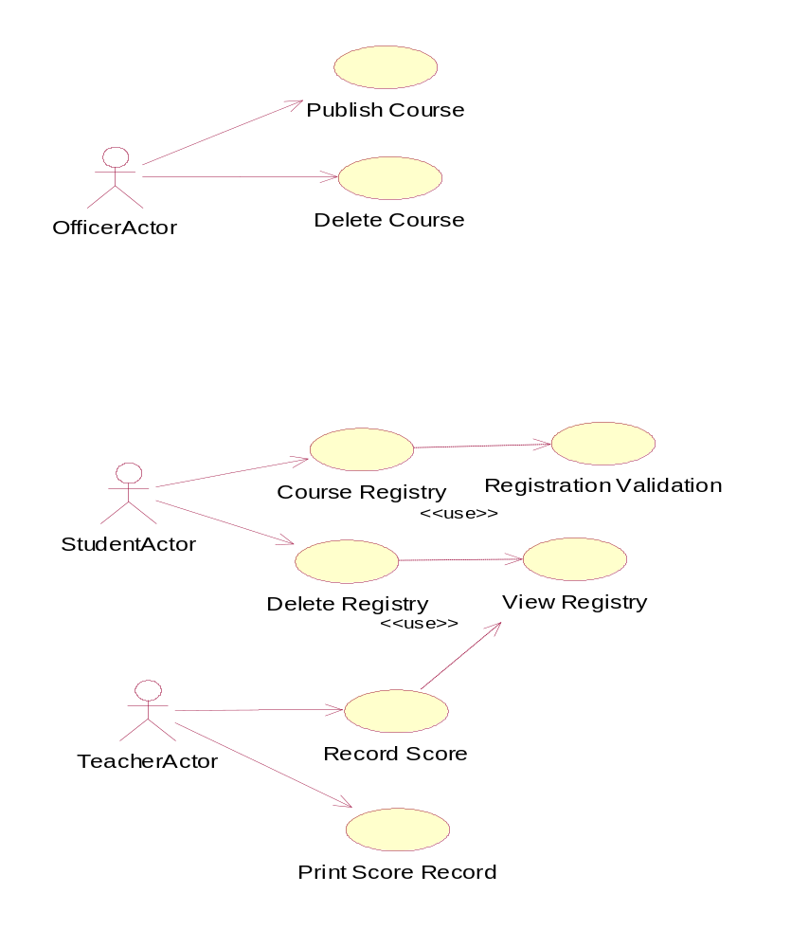
- Detailed class diagram (15 marks)

Grading standard:
- 7 marks for the basic class structure
- 4 marks for the attributes
- 4 marks for the attributes

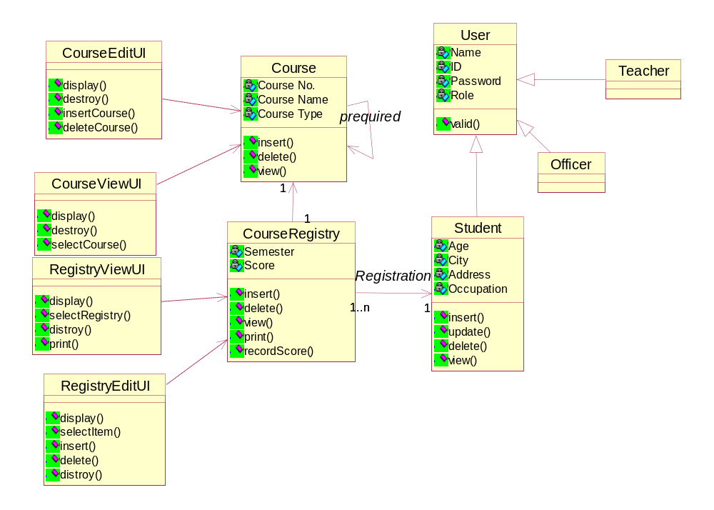

- Sequence diagram (15 marks)
  - Course Administration (5 marks)

Grading standard:
    - 2 marks for the objects
    - 3 marks for the sequences

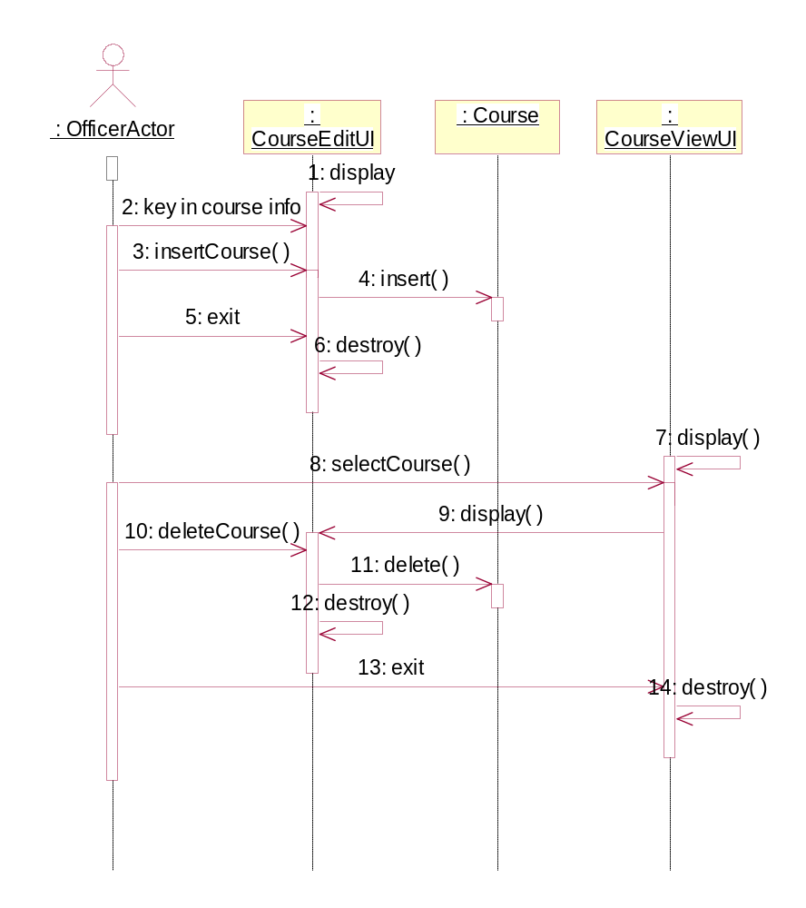
  - Course Registration (5 marks)

Grading standard:
    - 2 marks for the objects
    - 3 marks for the sequences

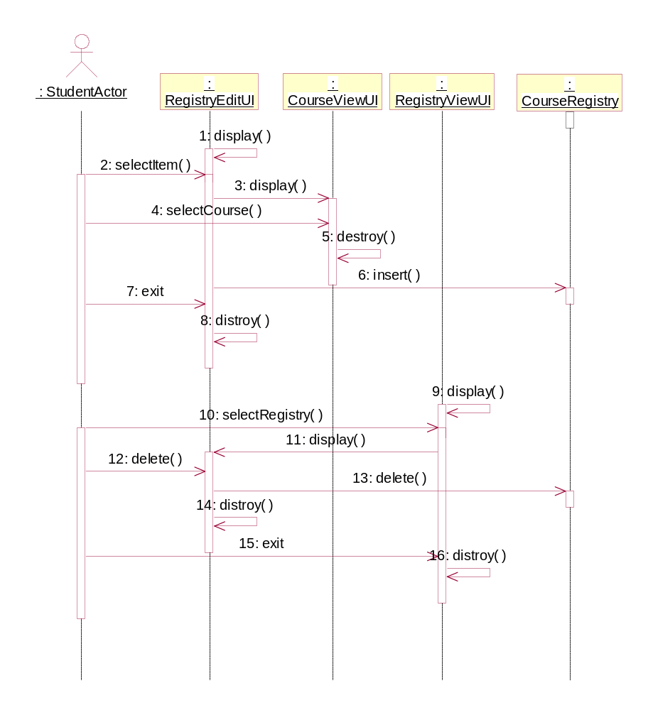

  - Course Record Score (5 marks)

Grading standard:
    - 2 marks for the objects
    - 3 marks for the sequences

